NAME: OLOGUN GODWIN
STUDENT NO: CS-C26-09-NA-005
COURSE: NETWORKING CAPSTONE PROJECT

These are the following steps deployed on the project of the networking. There are as follows:
The first steps were the topology in cisco packet tracer.
The first process is to Open Cisco Packet Tracer. From the bottom device panel, drag the required routers, switches, PCs, and other devices into the workspace, Select the appropriate cable from Connections. We are to use the Straight-Through cable to connect all the device, Switch, Router and Server. server to switch PCs, switch to Router, switch to PCs. depends on the interfaces and topology.
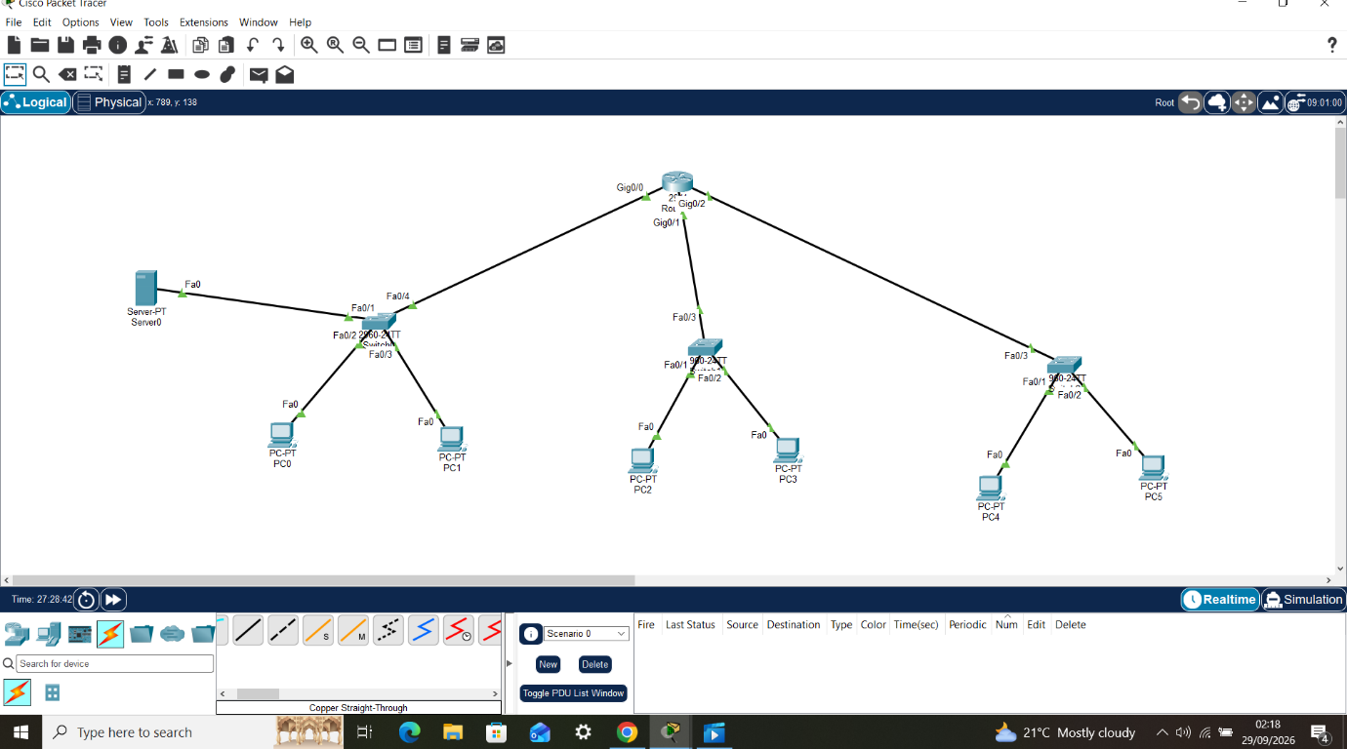
The second steps were talking about the IP configuration from PC to the department. The first place to start the configuration is from the server because it will be the one that will serve all the department, when you click on it you will also click on service then you chose the DHCP.
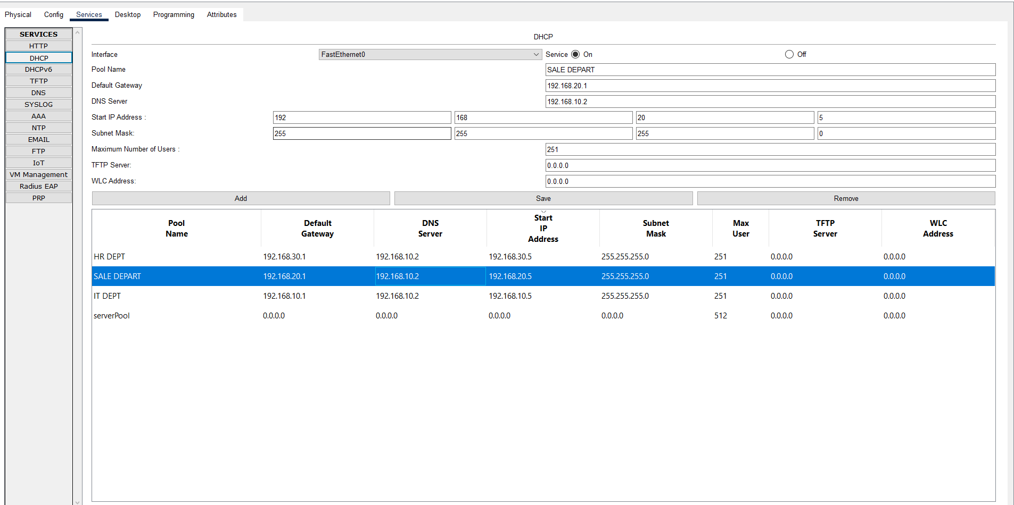

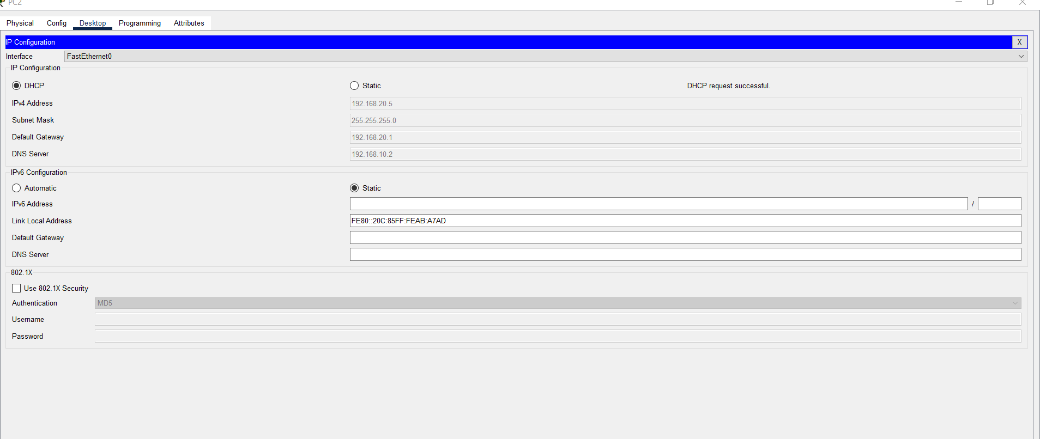
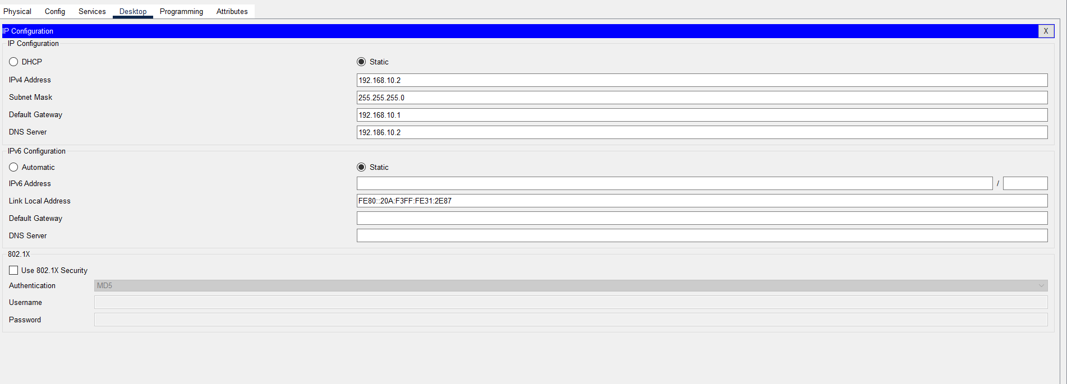

The third steps showed the success of the ping
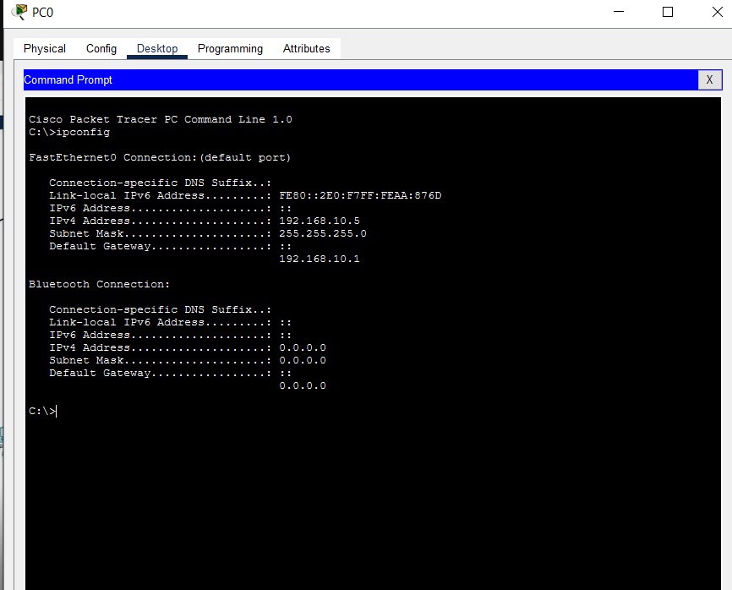

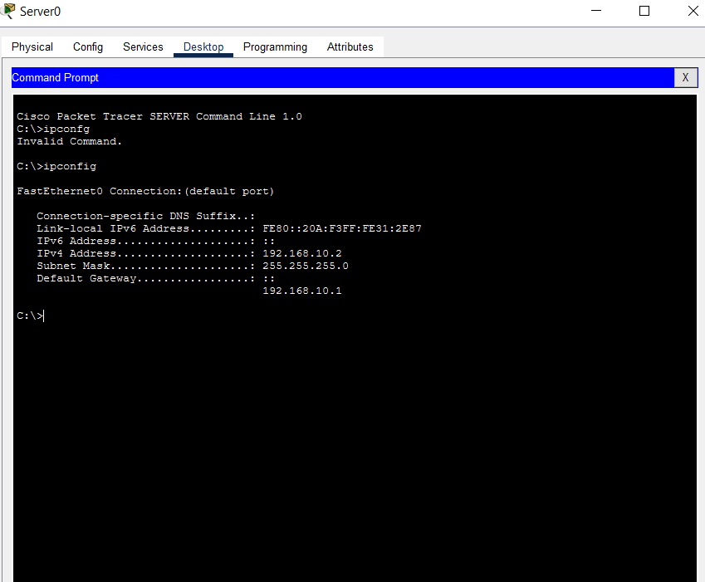

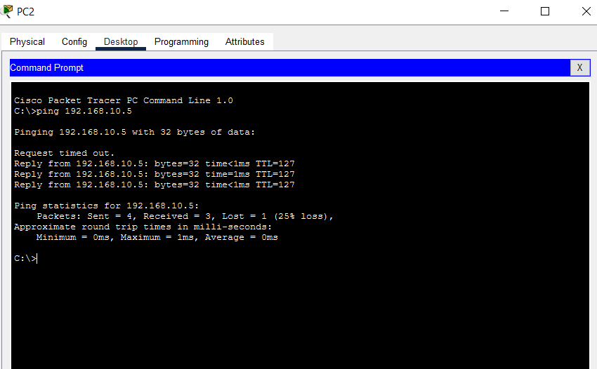
The fourth steps also showed the failed ping from the various department. These was the failed ping command
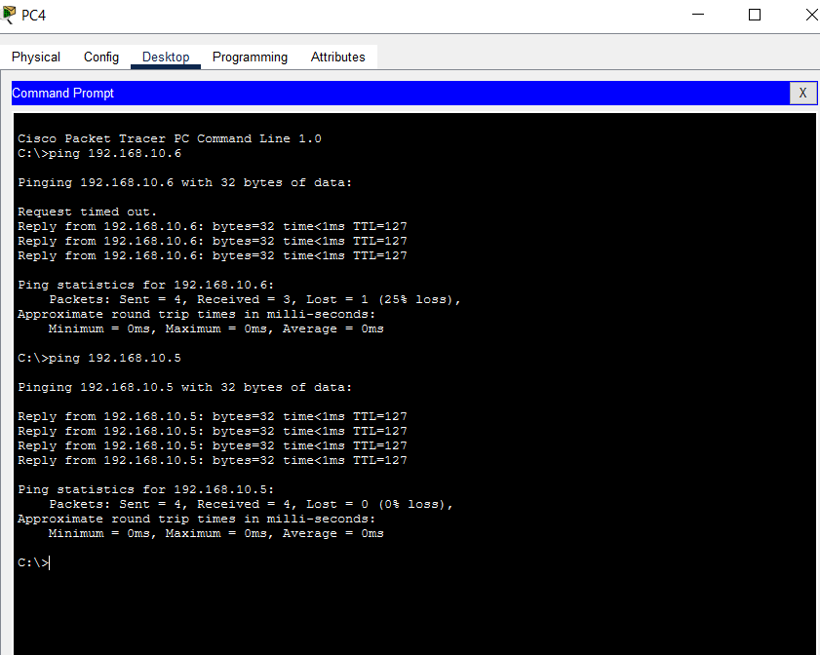

The fifth showed the way the ACL command was linked to the router.
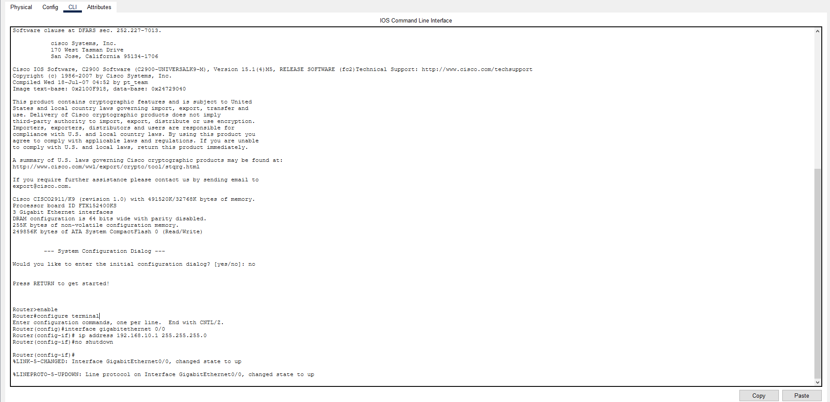
Click on the PC → Desktop → IP Configuration
You will now see this IP Address, Subnet Mask, Default Gateway, DNS Server. Choose DHCP or Static. The network has a DHCP server/router, select DHCP. The PC should automatically receive an IP address.

Department PC IP Address Subnet Gateway

IT PC1 192.168.10.1 255.255.255.0 192.168.10.5

SALES PC2 192.168.20.1 255.255.255.0 192.168.20.5

HR PC3 192.168.30.1 255.255.255.0 192.168.30.5

Click the HR PC → Desktop → Command Prompt and run: ipconfig
IP Address : 192.168.30.10
Subnet : 255.255.255.0
Default gateway : 192.168.30.1

The last steps showed how the http services of the server
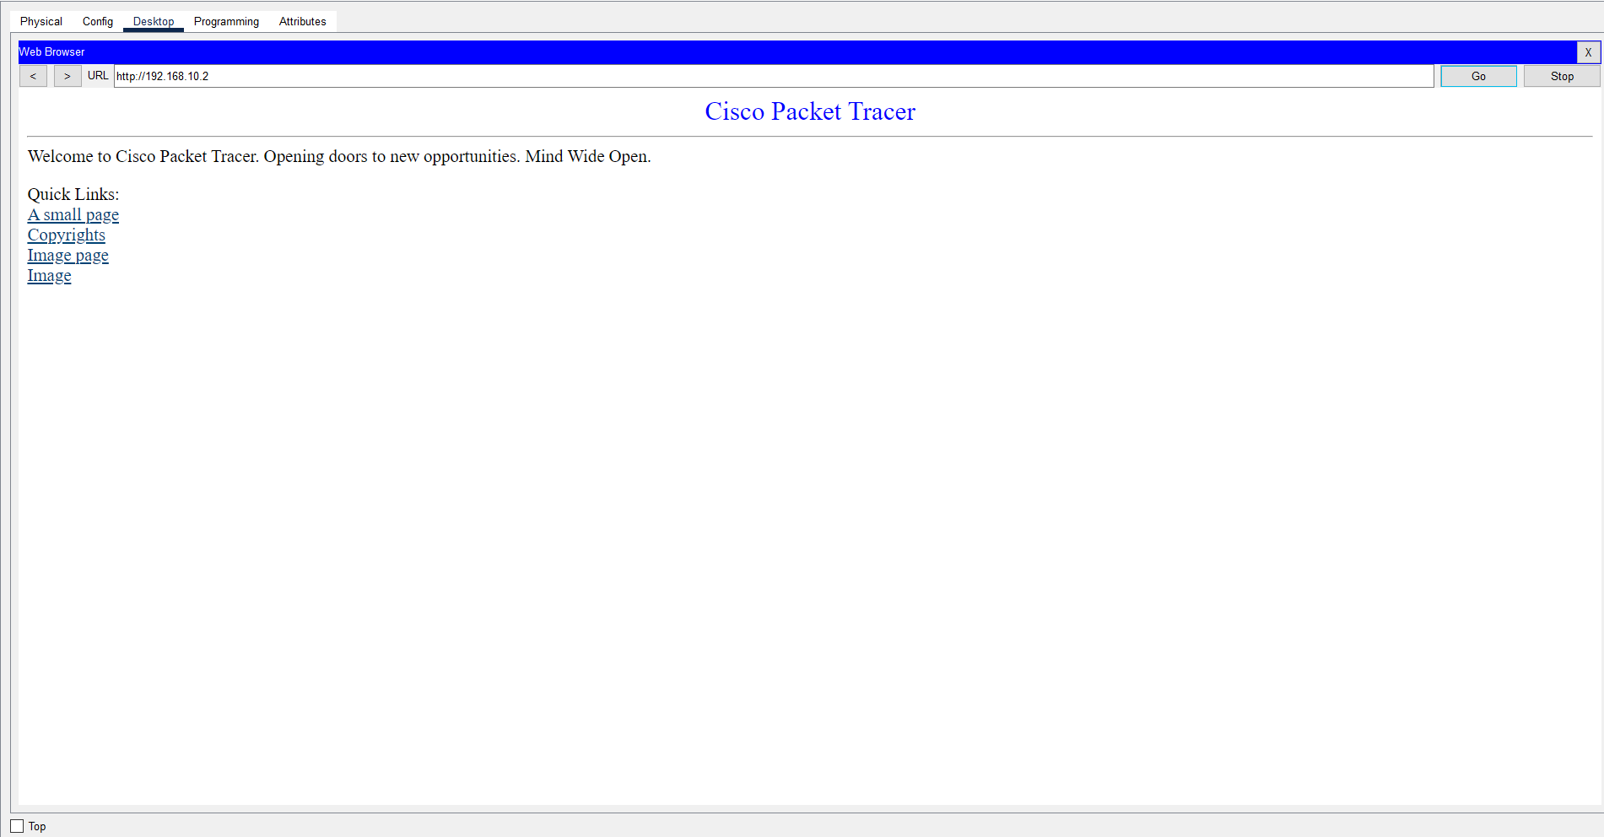You will click on the sales PC to desktop to command prompt and run it with: ipconfig.

